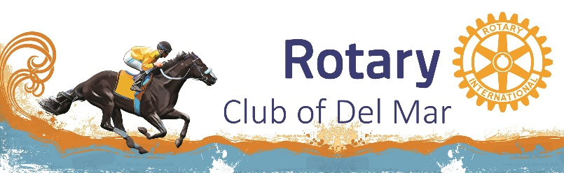
Rotarians of the Year
1970’S Don Barley
1970’s Monty Woolley
1979 Barney Barnhardt
1980 Bill Jacox
1981 Ralph Robinson
1982
1983 Ed Eginton
1984 Jim Watkins
1985 Bill Dougherty
1986 John Daily
1987 Tally Jarrett
1988 Hal Friedland
1989 Don Lapham
1990 Dick Wheelock
1991 Bill Tatum
1992 Jim Bond
1993 Bill Merritt
1994 Marty Peters
1995 Nick Longo
1996 Hank Russell
1997 Nick Rugen
1998 Al Graff
1999 Ray Yuen
2000 Roger Kingston / Ed Johnson
2001 Ed Siegel
2002 Ken Paulovich
2003 Bonnie McCassy
2004 Jim Crosby / Pat Dougherty
2005 Rob Mullally
2006 Cal Mann
2007 Charles L. (Larry) Simmons
2008 Rob Morse
2009 Janice Kurth
2010 Bob Fuchs / Eric Nelte
2011 Sharyn Daly
2012 Val Myers
2013 Mark Henshaw
2014 Mark Matthess
2015 John Burnett
2016 Karin and Jim Davies
2017 Kit Leeger and Paul Chunyk
2018 Sharon Schendel
2019 Karin Davies
2020 Dugan Lamoise

