ANNUAL PLEDGE FORM

Dear Rotarian,

During the next couple of months, our rotary club will focus on donations to Rotary Club of Del Mar Foundation Trust.

The Rotary Club of Del Mar Foundation Trust is a 501(c)(3) charitable organization with the mission of supporting the service projects of the Rotary Club of Del Mar. The Rotary Club of Del Mar Foundation Trust is a separate organization with its own trustees. Funds given to the Rotary Club of Del Mar Foundation Trust are tax deductible. Payments made directly to the Rotary Club of Del Mar, which is not a tax exempt service organization, are not tax deductible.

The Rotary Club of Del Mar Foundation Trust supports initiatives approved and managed by the following Rotary Club of Del Mar committees:
- Youth Services
- Community Service
- International Services
- Vocational Services
- Club Service

We appreciate that many of you generously donate and trust that you will continue, which helps the Rotary Club of Del Mar Foundation Trust meet our goal of averaging $200 per member; But, our main goal is 100% participation. Please complete and return this pledge form telling us what you are able to contribute by December 31. Contributions can be made in installments during the Rotary Year, but are best made during the tax year 2018.

Thanks for your continuing support to the Rotary Club of Del Mar Foundation Trust.

Klaus Gubernator Val Myers
Trustee and Treasurer Trustee and Chair

Name: ________________________________ Date: __________________

2018-19 Annual Pledge: __ $500 __ $200 __ $100 __ $25 __ Other $______

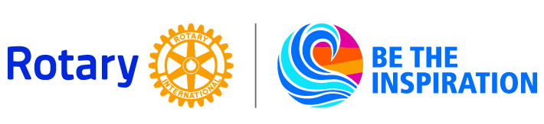
Write your check to Rotary Club of Del Mar Foundation Trust.

