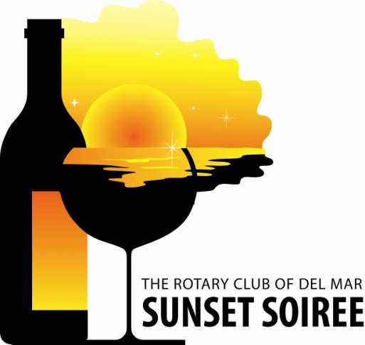
DEL MAR ROTARY SUNSET SOIREE
DONATION FORM
Thank you for your support of our charity event!
A high resolution ad copy is helpful to recognize your business in our donor booklet and advance event advertising.
To receive maximum recognition for your participation during this event, this form must be returned to Rotary Club of Del Mar PO Box 552, Del Mar, CA 92014 by Tuesday, May 15, 2018. Or email to S. Wagner: Wagsduos@gmail.com
Your business sponsorship of Rotary Club of Del Mar, an IRC 501(c)(4) organization, may be tax-deductible as a promotional expense. If you prefer, check here [_____] so your donation will instead support the Rotary Club of Del Mar Foundation Trust, an IRC 501(c)(3) public charity that can receive tax-deductible charitable contributions.

Company Name (as it should appear):______________________________________________
Contact: _____________________________ Title: _____________________________________
Address: ______________________________________________________________________
City: ___________________________________ State: _______ Zip Code: _________________
Telephone: _____________________________ Fax: ___________________________________
Email: _____________________________ Signature: _____________________________
ITEM DESCRIPTION: VALUE: $_______________
_________________________________________________________________________
_________________________________________________________________________
Restrictions and/or expiration date on gift certificate*: ___________________________________
*Please note the date of the event is TUESDAY, May 15, 2018
Please check one: Certificate enclosed Merchandise will be delivered
Merchandise attached Merchandise needs pickup *
Please make a certificate *Rotary Contact: Susan Wagner 858 334-8338
Return to the Rotary Club of Del Mar by Tuesday, May 15, 2018
Rotary Motto: “SERVICE ABOVE SELF” Mail: PO Box 552, Del Mar, Ca 92014

